# Analysis of the Change in Thickness of Macular Retinal Layers due to Glaucoma

# Abstract

Purpose: To compare the thickness of the macular layers between eyes diagnosed with primary open-angle glaucoma (POAG) and/or ocular hypertension and healthy eyes, and to identify the macular regions that can contribute to an early POAG diagnosis.

Materials and Methods: 998 individuals were enrolled, of whom 765 were healthy subjects and 233 were ocular hypertensive and/or glaucomatous patients. Spectral domain optical coherence tomography (SD-OCT) was used to measure the thickness of the 64 cells of an 8x8 mm grid of the macular layers: retinal nerve fibre layer (RNFL), ganglion cell layer (GCL), inner plexiform layer (IPL), inner nuclear layer (INL), outer plexiform and nuclear layer (OPL+ONL), photoreceptors layer (PRL) and retinal pigment epithelium (RPE). The cells were analysed separately and by grouping the cells into hemispheres and into quadrants. For each layer a comparison of the mean thickness of the cells between glaucomatous and healthy subjects was performed using Student’s t-test. Differences in means for all cells were plotted on an 8x8 heat map.

Results: Thinning of mean thickness in RNFL, GCL and IPL was found in the POAG group for all the hemispheres and quadrants, the lower nasal quadrant being the one with the highest degree of thinning. Heatmaps showed regular thinning patterns in these layers. In INL and outer retinal layers heatmaps showed irregular patterns and no significant differences were found.

Conclusions: POAG produces a significant thinning of inner retinal layers (except for INL) especially in lower nasal region of the macula. SD-OTC can be used to detect this thinning and diagnose POAG.

# INTRODUCTION

Primary open-angle glaucoma (POAG) has been defined by the American Academy of Ophthalmology as a multifactorial optic neuropathy, in which there is an acquired and progressive loss of retinal ganglion cells (GC), which causes characteristic damage to the optic nerve head due to the disappearance of retinal nerve fibres, resulting in visual field (VF) loss.1

Although the macula represents less than 2% of the retinal surface, it contains more than 30% of the ganglion cells, and theoretically would be an ideal place for early detection of ganglion cell loss, as proposed by Corsacio in 1990.2

Zeimer stated that retinal thickness could indicate the progression of glaucoma, and several subsequent works pursued the idea of assessing retinal thickness using different techniques.3-7

Ishikawa, in 2005, proposed an algorithm for automated segmentation of retinal layer structures in linear macular optical coherence tomography (StratusOCT; Carl Zeiss Meditec, Inc., Dublin, CA), with resolutions of 50 microns, and suggested the importance of GC and RNFL in glaucoma.8

With current diagnostic tools and the contributions of various authors on the behaviour of the retinal nerve fibre layer (RNFL) and peripapillary rings in POAG, other cell layers and other ocular areas –not only GC– are being considered.9

The extremely rapid development of optical coherence tomography (OCT), both in terms of resolution and speed of capture, has made it possible to quantify thicknesses in the retinal nerve fibre layers (RNFL) and in areas beyond the retina and the peripapillary rings. Thanks to the work of Chauhan et al. on measuring the BMO-MRW ring, we can know the real limits of the optic nerve (ON) papilla, both those of normal and of atypical morphology, which go beyond what we perceive with our eyes or photographic techniques, and we can quantify the alterations in their values in processes such as glaucoma.10

Spectral domain optical coherence tomography (SD-OCT) gives us three-dimensional images of ocular structures, and new models in light-source technology have improved image resolution, allowing for better segmentation of retinal layers, more accurate measurements, fewer artifacts and, ultimately, better reproducibility of OCT parameters.1,11,12

MFL segmentation has shown correlations between this area and neurodegenerative processes in diseases such as Parkinson’s, multiple sclerosis, etc. This highlights the importance attributed to this area and its segmentation.13-16

Obviously, POAG could not be left out of these considerations, and many studies have offered varying opinions about RFNL behaviour at macular level (MFL) and whether their values were more or less predictive than the layers in the peripapillary rings. It has also been studied whether factors such as sex, age, axial length, etc. distort the thinning of GC and other layers. 9,12,17-19

# PATIENTS, MATERIALS AND METHODS

## Study Design and Population

We planned an analytical, observational, cross-sectional and comparative study of ocular hypertension patients and POAG patients, consecutively recruited at Policlínica Baza and Clínica Vistacamacho (Almeria, Spain) between May 2016 and June 2018.

The study involved 998 individuals, 233 of them with hypertension and/or glaucoma.

The patients were informed about the nature of the study and gave their informed consent in accordance with current data protection law. Patients’ personal data were anonymised. The study adhered to the conditions of the Declaration of Helsinki (sixth revision, 2008) and was approved by the ethics committee of the participating centres.

Patients underwent a complete ophthalmological examination at the inclusion session comprising cyclopegic refraction (Tropicamide 1%), best-corrected visual acuity (VA), central corneal thickness (CCT) measurement by ultrasound pachymetry, slit-lamp examination and gonioscopy under dilation, retinal and optic nerve fundoscopy with slit lamp and 78 dioptre hand lens.

VF examinations were performed using the white-on-white SITA standard threshold strategy with a Humphrey II field analyser (software version 4, program 24-2, Goldmann size III lens, 200 ms stimulus duration, HFA 740 model (Humphrey Instruments, Inc., Dublin, CA, USA).

SD-OCT was performed with Heidelberg Spectralis (Heidelberg Engineering, GmbH. Germany, Heidelberg Eye Explorer software version 6.7c), with gaze tracking, posterior pole (PP) program and automatic segmentation.

The thickness of the 64 cells of an 8x8 mm grid was measured in each of the macular fibre layers: retinal nerve fibre layer (RNFL), ganglion cell layer (GCL), inner plexiform layer (IPL), inner nuclear layer (INL), outer plexiform layer + outer nuclear layer (OPL+ONL), photoreceptors layer (PRL) and retinal pigment epithelium (RPE). Outer plexiform and nuclear layers were considered joined because of the difficulty in segmenting them. The cells of the macular fibre cube (MFC) were analysed separately, and by grouping the cells into half-planes (superior-inferior and nasal-temporal) and into upper nasal (UN), lower nasal (LN), upper temporal (UT) and lower temporal (LT) quadrants.

The glaucoma software provided by the manufacturer was used. It has a patented anatomical positioning system (APS) with a series of patterns for scanning the optic nerve head, retinal nerve fibre layer and macular ganglion cell layer. The program compares patients’ eyes with a standardised base of normal eyes.

## Inclusion criteria

In order to be eligible for selection, all patients had to meet the following criteria: (A) cognitive ability to accept and understand the proposed procedures; (B) patients with a clinical record of intraocular pressure (IOP) > 23 were considered ocular hypertensive (OHT) if there was no visual field damage, normal optic papilla (NOP) and all sectors assessed by SD-OCT were in normal percentiles; (C) POAG with historical clinical had records of IOP > 23 at least once. Such patients had to have received antihypertensive treatment and/or surgery six months earlier and had to have a minimum of two clinical records (VF < 20% false negative and false positive responses, and < 20% fixation losses) as well as accepted glaucomatous defects according to the Hodapp classification; (D) Caucasian origin; (E) absence of retinal or optic nerve diseases; (F) open-angle verification by gonioscopy, as well as no signs of pseudo-exfoliation and pigment.

## Exclusion criteria

Patients considered to be ocular hypertensive or POAG were excluded from the study if they: (A) did not cooperate in the examination or did not accept inclusion; (B) had a direct family history of cognitive neurodegenerative processes or exhibited suspicious signs thereof; (C) retinal and optic nerve diseases at time of inclusion or previously; (D) had undergone intraocular surgery in the previous six months, except for successful cataract operations or surgery related to POAG; (E) exhibited non-transparent media at any level; (F) had severe systemic diseases; (G) had refractive errors above the spherical equivalent of 3 dioptres; (H) had SD-OCT tests with signal strength of below 20; (I) were initially considered hypertensive and did not have high IOP values again after three months of antihypertensive treatment and discontinuation of such treatment.

## Statistical analysis

Statistical analysis was carried out with R (version 3.5), RKWard (version 7.0) and the rk.Teaching package (version 1.3).20

The quantitative variables corresponding to thickness of layers in MFL cells were tested for normality using the Kolmogorov-Smirnov test with a p-value of 0.05.

For each retinal layer, a correlation analysis was performed between MFL cells, showing the Pearson correlations with a blue gradient for positive correlations (the darker the stronger) and a red gradient for negative correlations (the darker the stronger) in a matrix.

For each retinal layer, a comparison of the mean thickness of each MFL cell between glaucomatous and healthy subjects was performed using Student’s t-test for the difference in means of independent populations. A p-value < 0.05 was considered significant, and a p-value < 0.01 was considered highly significant. Differences in means for all cells were plotted on an 8x8 heat map representing the cells of the macular matrix, using a blue gradient for positive differences (the darker the larger) and a red gradient for negative differences (the darker the smaller). In each cell the significance of the difference in means was also indicated with colours (black for non-significant, yellow for significant and green for highly significant).

A comparison of mean layer thickness between glaucomatous and healthy subjects was also performed by half-plane (superior (S), inferior (I), nasal (N) and temporal (T)), as well as by quadrant (upper nasal (UN), lower nasal (LN), lower temporal (LT) and upper temporal (UT)), aggregating the cell thicknesses of each half-plane or quadrant, also using Student’s t-test for independent populations.

# RESULTS

Table 1 shows the breakdown of healthy and glaucomatous subjects by sex.

Table 1. Breakdown of healthy and glaucomatous subjects by sex.

|  |  |  |  |
| --- | --- | --- | --- |
| Glaucoma | Men | Women | Total |
| No | 325 | 440 | 765 |
| Yes | 131 | 102 | 233 |
| Total | 456 | 542 | 998 |

 The average ages of healthy and glaucomatous subjects are shown in Table 2.

Table 2. Average ages of healthy and glaucomatous subjects by sex.

|  |  |  |
| --- | --- | --- |
| Glaucoma | Sex | Average age |
| No | Male | 48.9 |
| No | Female | 46.5 |
| Yes | Male | 65.0 |
| Yes | Female | 69.3 |

According to the Kolmogorov-Smirnov test, all variables presented normal distribution.

## RNFL

According to the correlation matrix of macular cube cells in Error: Reference source not found, no strong correlation between the thickness of the cells was observed in the RNFL, with the exception of contiguous cells. The negative, albeit weak, correlation of cells 5.2 and 5.3 with almost all the others is striking.

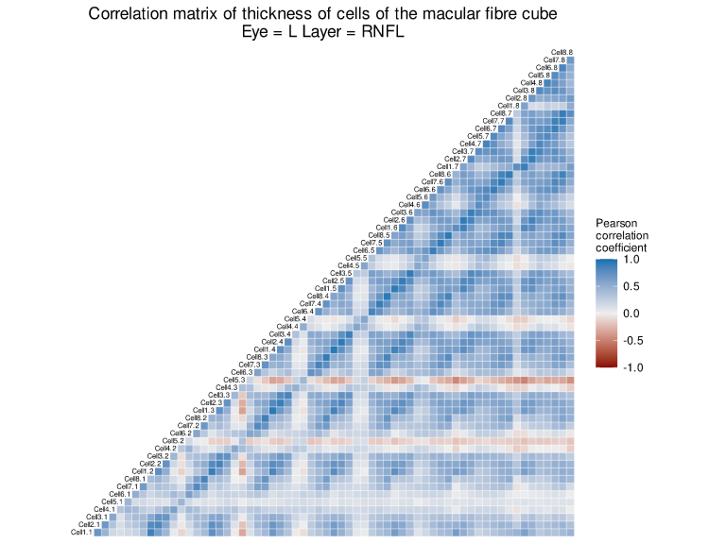

Figure 1. Correlation matrix of thickness of RNFL cells of the macular fibre cube of left eyes (right eyes present the same behaviour).

In the comparison of the mean thickness of RNFL cells (Error: Reference source not found), statistically highly significant differences were observed in the mean thickness of nearly all the cells in healthy and glaucomatous subjects, with the exception of some central cells. The largest differences were observed in the cells of the lower and upper nasal region, particularly in cells 8.2, 7.2, 8.1, 8.8 and 8.7. On the other hand, the smallest differences were observed in the central cells and in the temporal region; in particular, cells 5.2, 5.3, 5.4, 4.1, 4.2 and 4.3 present negative differences, i.e., they are thicker in glaucomatous than in healthy eyes, albeit not by much. The pattern is repeated in both left and right eyes, showing an almost perfect symmetry.

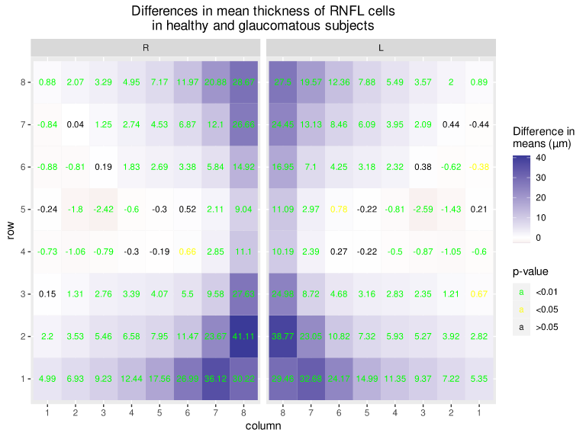

Figure 2. Heat map of differences in mean thickness (in µm) of RNFL cells in healthy and glaucomatous subjects, according to left and right eyes.

In the comparison by upper and lower half-plane (Error: Reference source not found), statistically significant differences were observed in the mean thickness of the RNFL in healthy and glaucomatous subjects in both half-planes, for both left and right eyes. The difference in means in the inferior half-plane was significantly greater than in the upper half-plane.

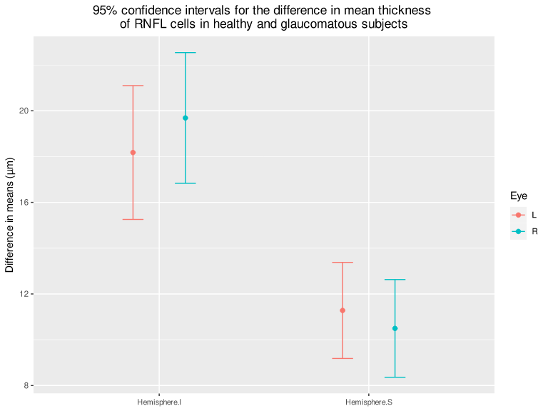

Figure 3. 95% confidence intervals for the difference in mean thickness of RNFL cells in healthy and glaucomatous subjects, according to upper and lower half-planes and left and right eyes.

In the comparison by temporal and nasal half-plane (Error: Reference source not found), statistically significant differences were observed in the mean thickness of the RNFL in healthy and glaucomatous subjects in both half-planes, for both left and right eyes. The difference in means in the nasal half-plane was significantly greater than in the temporal half-plane.

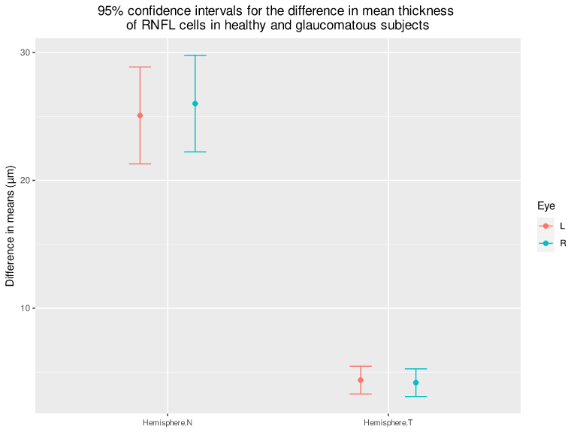

Figure 4. 95% confidence intervals for the difference in mean thickness of RNFL cells in healthy and glaucomatous subjects, according to temporal and nasal half-planes, and left and right eyes.

In the comparison by quadrant (Error: Reference source not found), statistically significant differences were observed in the mean thickness of the RNFL in healthy and glaucomatous subjects in all quadrants, for both left and right eyes. The difference in means in the lower nasal quadrant was significantly greater than in the other quadrants.

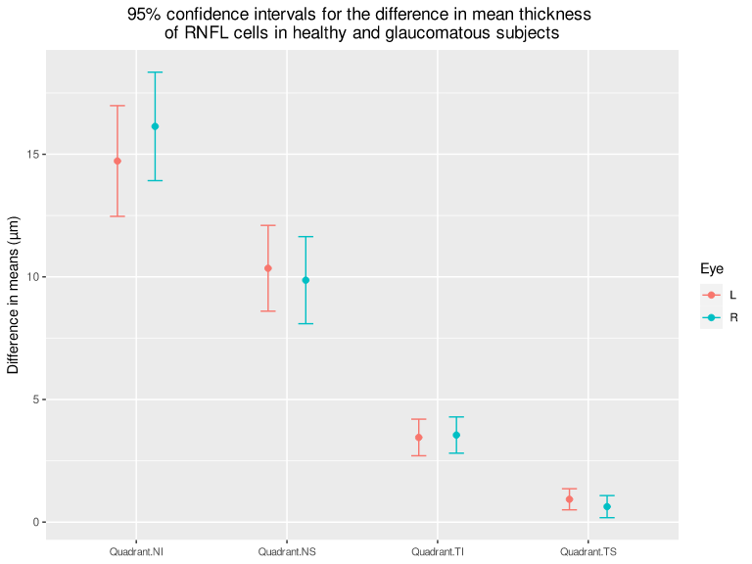

Figure 5. 95% confidence intervals for the difference in mean thickness of RNFL cells in healthy and glaucomatous subjects, according to quadrants and left and right eyes.

## GCL

According to the correlation matrix of macular cube cells in Error: Reference source not found, a moderate correlation was observed in the thickness of GCL cells, with the exception of contiguous cells, which show a strong correlation. The least correlated cells are 1.7, 1.8, 8.7 and 8.8.

Figure 6. Correlation matrix of thickness of GCL cells of the macular cube of left eyes (right eyes present the same behaviour).

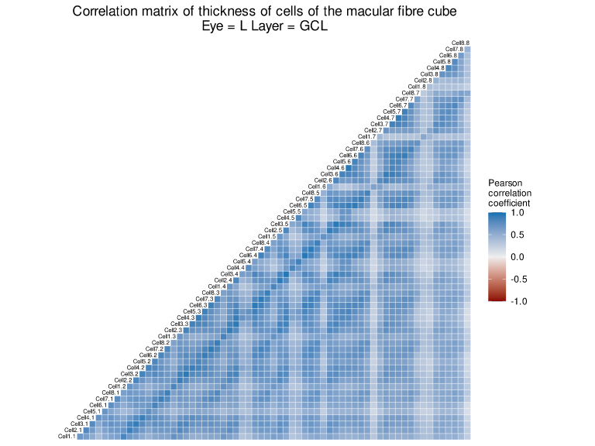

In the comparison of the mean thickness of GCL cells (Error: Reference source not found), statistically highly significant differences were observed in the mean thickness of nearly all cells in healthy and glaucomatous subjects, with the exception of cell 8.8. The largest differences were observed in the cells of the ring surrounding the central region of the macula, particularly in cells 3.3, 3.4, 3.5, 4.3 and 5.3. On the other hand, the smallest differences were observed in the cells on the edges of the macula. The pattern is repeated in both left and right eyes, showing an almost perfect symmetry.

In the comparison by upper and lower half-plane (Error: Reference source not found), statistically significant differences were observed in the mean thickness of the GCL in healthy and glaucomatous subjects in both half-planes, for both left and right eyes. Unlike in the RNFL, no statistically significant difference was observed between the differences in means of the half-planes.

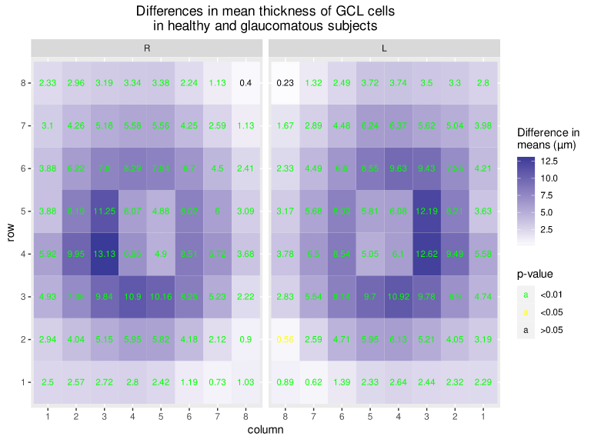

Figure 7. Heat map of differences in mean thickness (in µm) of GCL cells in healthy and glaucomatous subjects, according to left and right eyes.

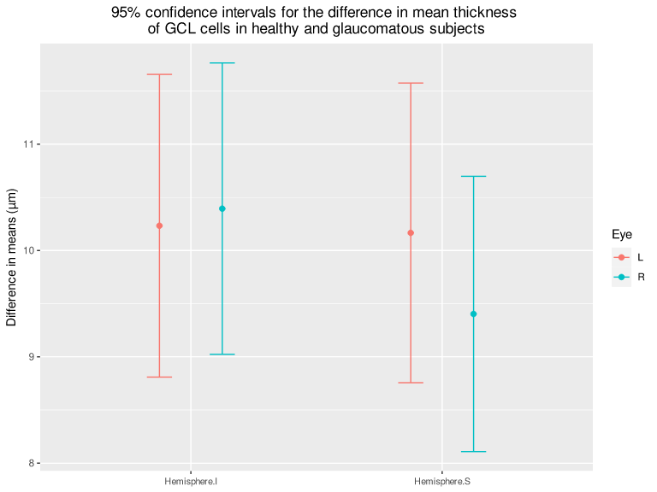

Figure 8. 95% confidence intervals for the difference in mean thickness of GCL cells in healthy and glaucomatous subjects, according to upper and lower half-planes and left and right eyes.

In the comparison by temporal and nasal half-plane (Error: Reference source not found), statistically significant differences were observed in the mean thickness of the GCL in healthy and glaucomatous subjects in both half-planes, for both left and right eyes. The difference in means in the temporal half-plane was significantly greater than in the nasal half-plane.

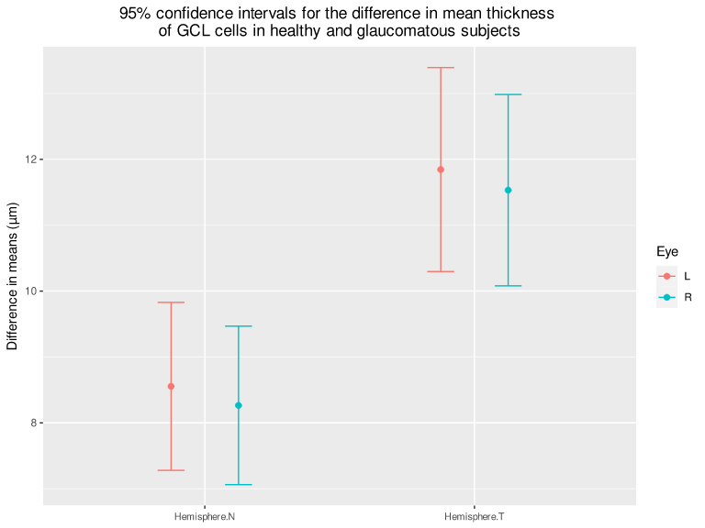

Figure 9. 95% confidence intervals for the difference in mean thickness of GCL cells in healthy and glaucomatous subjects, according to temporal and nasal half-planes and left and right eyes.

In the comparison by quadrant (Error: Reference source not found), statistically significant differences were observed in the mean thickness of the GCL in healthy and glaucomatous subjects in all quadrants, for both left and right eyes. The differences in means in the temporal quadrants were significantly greater than in the nasal quadrants.

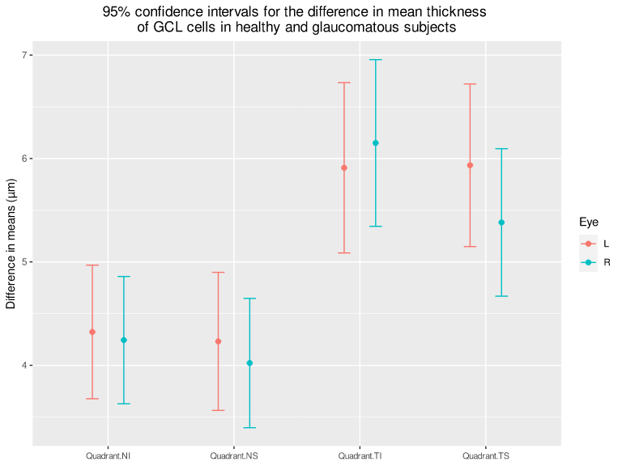

Figure 10. 95% confidence intervals for the difference in mean thickness of GCL cells in healthy and glaucomatous subjects, according to quadrants and left and right eyes.

## IPL

According to the correlation matrix of macular cube cells in Error: Reference source not found, a moderate correlation was observed in the thickness of IPL cells, with the exception of contiguous cells, which show a strong correlation. The least correlated cells are 1.7, 1.8, 8.7 and 8.8, as occurs with the GCL.

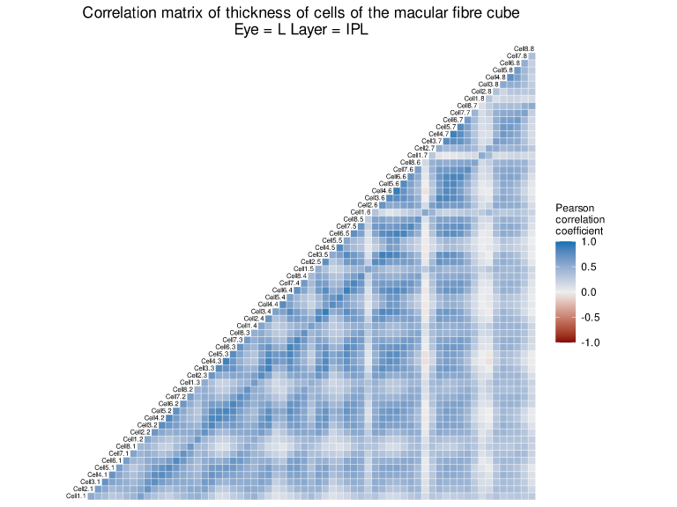

Figure 11. Correlation matrix of thickness of IPL cells of the macular cube of left eyes (right eyes present the same behaviour).

In the comparison of the mean thickness of IPL cells (Error: Reference source not found), statistically highly significant differences were observed in the mean thickness of nearly all the cells in healthy and glaucomatous subjects, with the exception of cell 8.8. As in the GCL, the largest differences were observed in the cells of ring surrounding the central region of the macula, particularly in cells 4.3, 5.3, 3.4 and 3.5. Likewise, the smallest differences were observed in the cells on the edges of the macula. The pattern is repeated in both left and right eyes, showing an almost perfect symmetry.

In the comparison by upper and lower half-plane (Error: Reference source not found), statistically significant differences were observed in the mean thickness of the IPL in healthy and glaucomatous subjects in both half-planes, for both left and right eyes. Unlike in the RNFL, no statistically significant difference was observed between the differences in means of the half-planes.

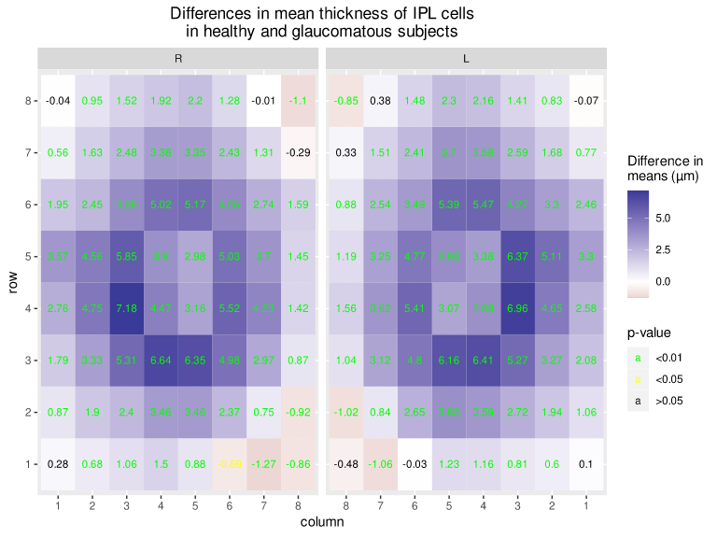

Figure 12. Heat map of differences in mean thickness (in µm) of IPL cells in healthy and glaucomatous subjects, according to left and right eyes.

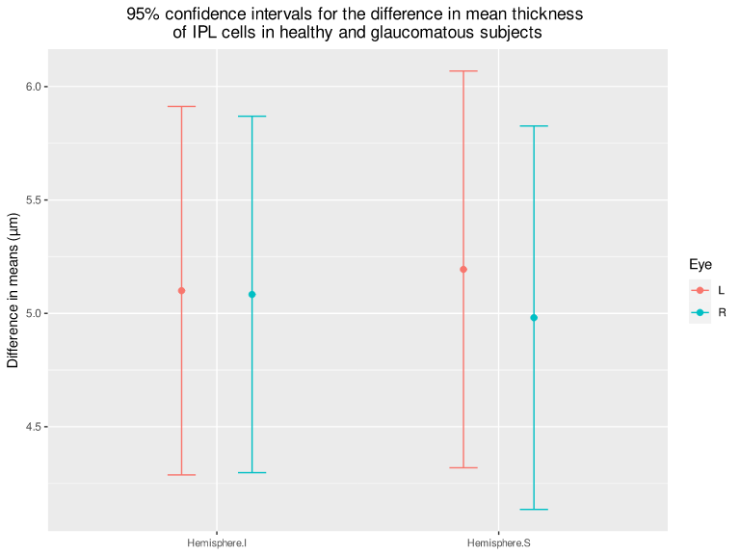

Figure 13. 95% confidence intervals for the difference in mean thickness of IPL cells in healthy and glaucomatous subjects, according to upper and lower half-planes and left and right eyes.

In the comparison by temporal and nasal half-plane (Error: Reference source not found), statistically significant differences were observed in the mean thickness of the IPL in healthy and glaucomatous subjects in both half-planes, for both left and right eyes. No statistically significant difference was observed between the differences in means of the half-planes.

Figure 14. 95% confidence intervals for the difference in mean thickness of IPL cells in healthy and glaucomatous subjects, according to temporal and nasal half-planes and left and right eyes.

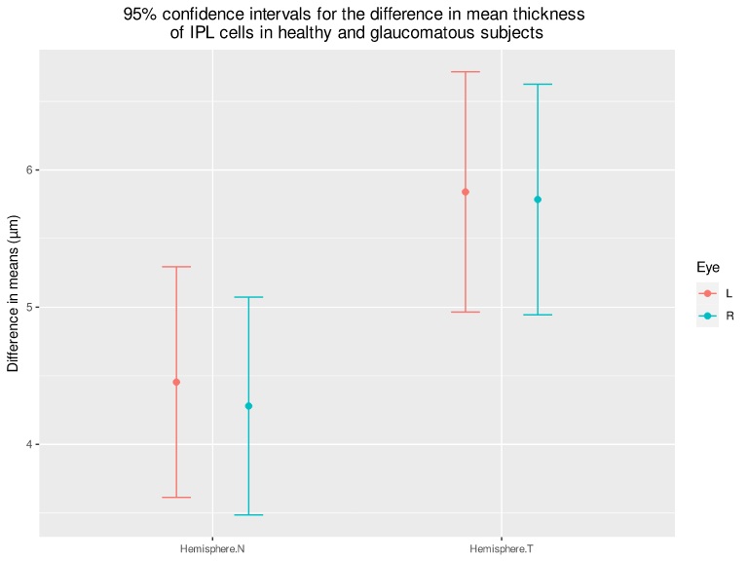

In the comparison by quadrant (Error: Reference source not found), statistically significant differences were observed in the mean thickness of the IPL in healthy and glaucomatous subjects in all quadrants, for both left and right eyes. No statistically significant differences were observed between the differences in means of the quadrants.

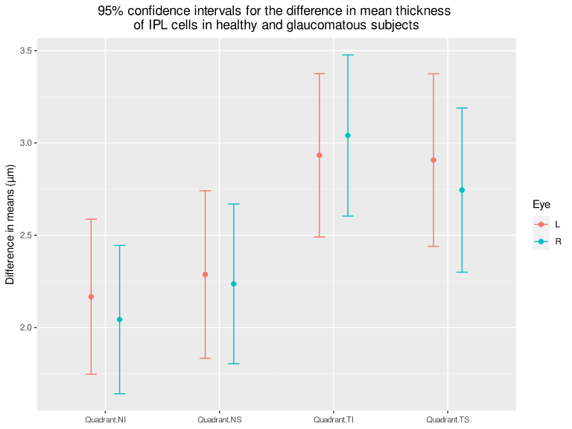

Figure 15. 95% confidence intervals for the difference in mean thickness of IPL cells in healthy and glaucomatous subjects, according to quadrants and left and right eyes.

## INL

According to the correlation matrix of macular cube cells in Error: Reference source not found, a moderate correlation was observed in the thickness of INL cells, with the exception of contiguous cells, which show a strong correlation. The least correlated cells are 1.7, 1.8, 8.7 and 8.8, and central cells 3.4, 4.4, 3.5 and 4.5.

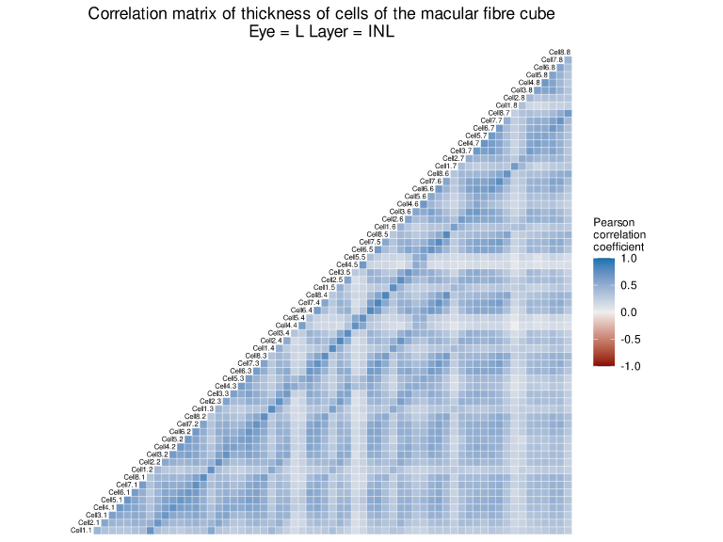

Figure 16. Correlation matrix of thickness of INL cells of the macular cube of left eyes (right eyes present the same behaviour).

In the comparison of the mean thickness of INL cells (Error: Reference source not found), unlike the other inner layers, no significant differences were observed in the mean thickness of nearly all the cells in healthy and glaucomatous subjects, with the exception of central cells 4.4, 4.5, 5.4 and 5.5 and some cells at the temporal margin. While the differences are positive at the temporal margin, in the central area the differences are negative. Nevertheless, the magnitude of the differences in both cases is small. The pattern is repeated in both left and right eyes, showing an almost perfect symmetry.

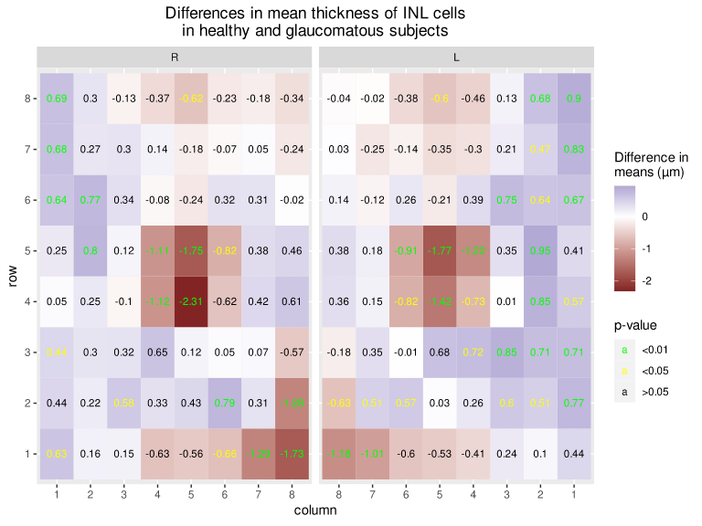

Figure 17. Heat map of differences in mean thickness (in µm) of INL cells in healthy and glaucomatous subjects, according to left and right eyes.

In the comparison by upper and lower half-plane (Error: Reference source not found), no statistically significant differences were observed in the mean thickness of the INL in healthy and glaucomatous subjects in both half-planes, for both left and right eyes. Likewise, no statistically significant difference was observed between the differences in means of the half-planes.

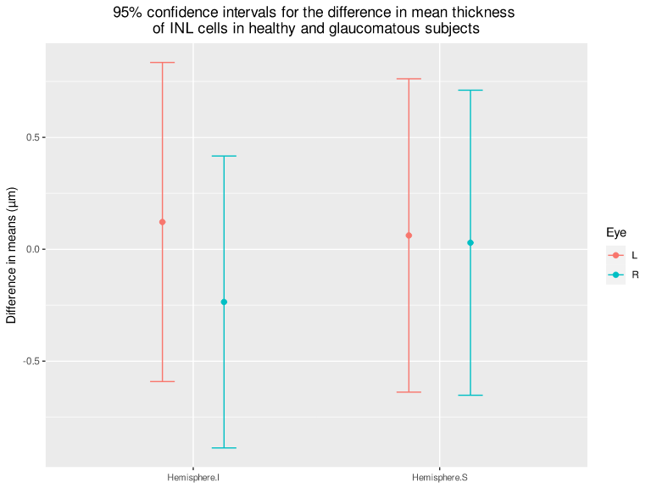

Figure 18. 95% confidence intervals for the difference in mean thickness of INL cells in healthy and glaucomatous subjects, according to upper and lower half-planes and left and right eyes.

In the comparison by temporal and nasal half-plane (Error: Reference source not found), no statistically significant differences were observed in the mean thickness of the INL in healthy and glaucomatous subjects in both half-planes, for both left and right eyes. Likewise, no statistically significant difference was observed between the differences in means of the half-planes.

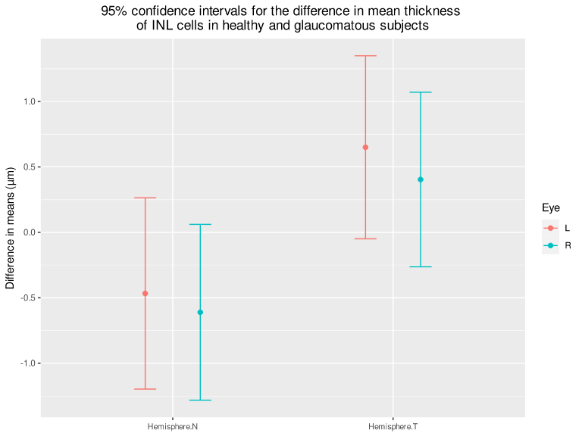

Figure 19. 95% confidence intervals for the difference in mean thickness of INL cells in healthy and glaucomatous subjects, according to temporal and nasal half-planes and left and right eyes.

In the comparison by quadrant (Error: Reference source not found), no statistically significant differences were observed in the mean thickness of the INL in healthy and glaucomatous subjects in all quadrants.

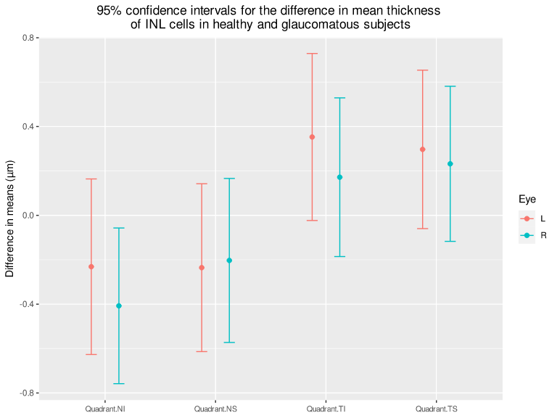

Figure 20. 95% confidence intervals for the difference in mean thickness of INL cells in healthy and glaucomatous subjects, according to quadrants and left and right eyes.

## OPL + ONL

According to the correlation matrix of macular cube cells in Error: Reference source not found, a moderate correlation was observed between the thickness of OPL+ONL cells, with the exception of contiguous cells, which show a strong correlation, and central cells 4.4, 4.5, 5.4 and 5.5, which barely correlate with the rest.

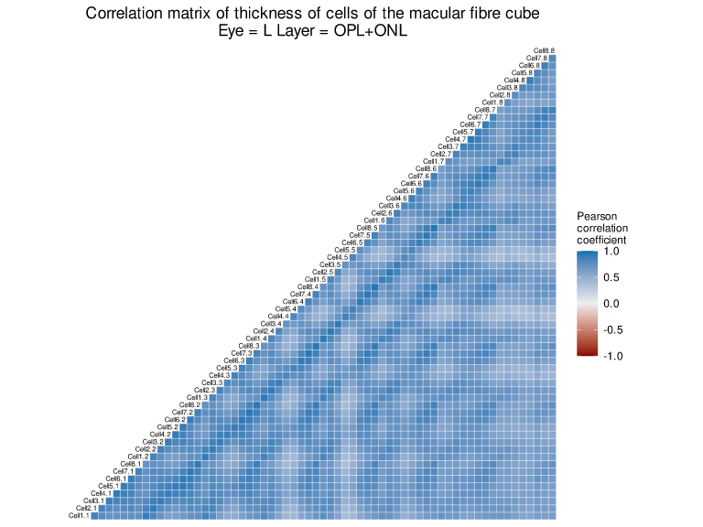

Figure 21. Correlation matrix of thickness of OPL+ONL cells of the macular cube of left eyes (right eyes present the same behaviour).

In the comparison of the mean thickness of OPL+ONL cells (Error: Reference source not found), an irregular pattern of differences in means in cell thickness was observed, with statistically significant positive differences in the cells of the first two rows of the upper region and statistically significant negative differences in cells 1.7 and 2.8. Nevertheless, the magnitude of the differences is small. The pattern is repeated in both left and right eyes, showing an almost perfect symmetry.

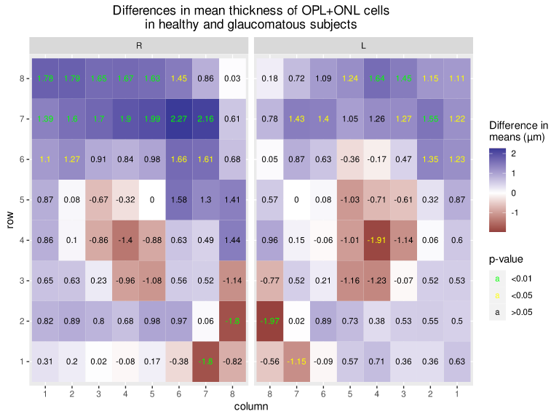

Figure 22. Heat map of differences in mean thickness (in µm) of OPL+ONL cells in healthy and glaucomatous eyes, according to left and right eyes.

In the comparison by upper and lower half-plane (Error: Reference source not found), no statistically significant differences were observed in the mean thickness of the cells in healthy and glaucomatous subjects.

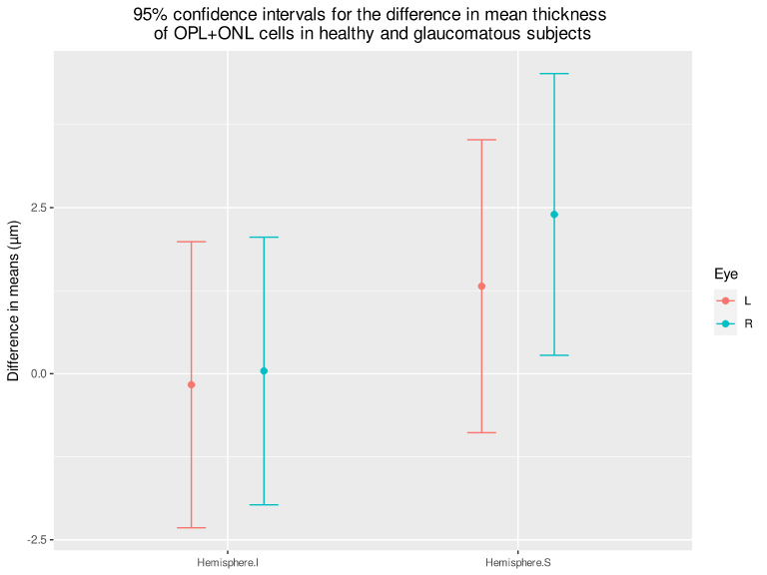

Figure 23. 95% confidence intervals for the difference in mean thickness of OPL+ONL cells in healthy and glaucomatous subjects, according to upper and lower half-planes and left and right eyes.

In the comparison by temporal and nasal half-plane (Error: Reference source not found), no statistically significant differences were observed in the mean thickness of the cells in healthy and glaucomatous subjects.

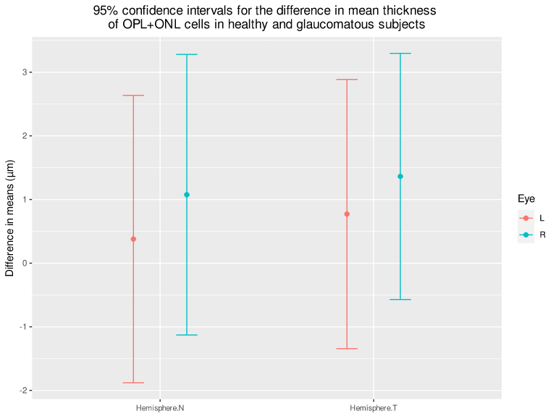

Figure 24. 95% confidence intervals for the difference in mean thickness of OPL+ONL cells in healthy and glaucomatous subjects, according to temporal and nasal half-planes and left and right eyes.

In the comparison by quadrant (Error: Reference source not found), no statistically significant differences were observed in the mean thickness of the cells in healthy and glaucomatous subjects.

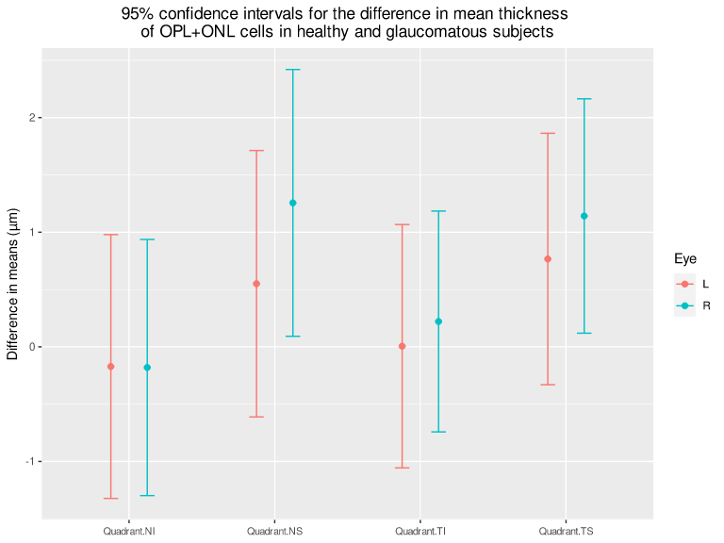

Figure 25. 95% confidence intervals for the difference in mean thickness of OPL+ONL cells in healthy and glaucomatous subjects, according to quadrants and left and right eyes.

## PRL

According to the correlation matrix of macular cube cells in Error: Reference source not found, a moderate correlation was observed in the thickness of PRL cells, with the exception of contiguous cells, which show a strong correlation, and central cells 4.4, 4.5, 5.4 and 5.5, which barely correlate with the rest.

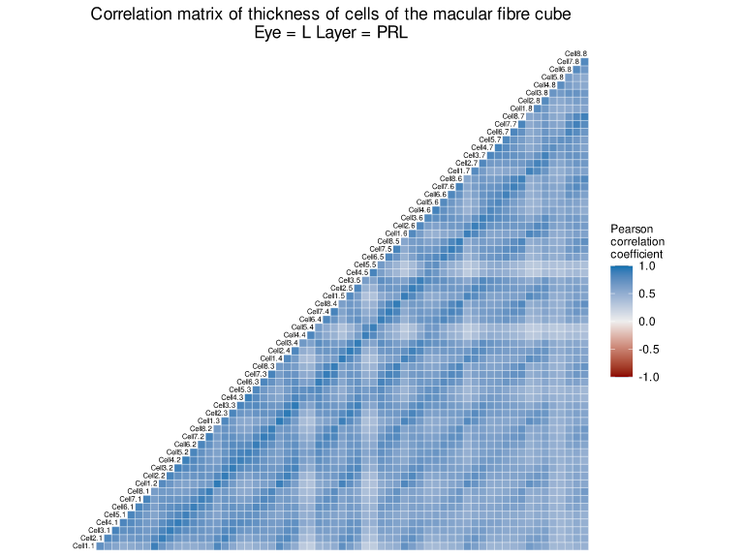

Figure 26. Correlation matrix of thickness of PRL cells of the macular cube of left eyes (right eyes present the same behaviour).

In the comparison of the mean thickness of PRL cells (Error: Reference source not found), very significant positive differences (p-valor<0.01) were observed in central cells 4.4, 4.5, 5.4 and 5.5 and in some cells of the first row of the upper region. Also, significant negative differences (p-valor<0.05) were observed in some cells of the first row of the lower region. Nevertheless, the magnitude of the differences, with the exception of these two cells, is small. The pattern is repeated in both left and right eyes, showing an almost perfect symmetry.

In the comparison by upper and lower half-plane (Error: Reference source not found), no statistically significant differences were observed in the mean thickness of the cells in healthy and glaucomatous subjects, with the exception of right eyes in the upper half-plane.

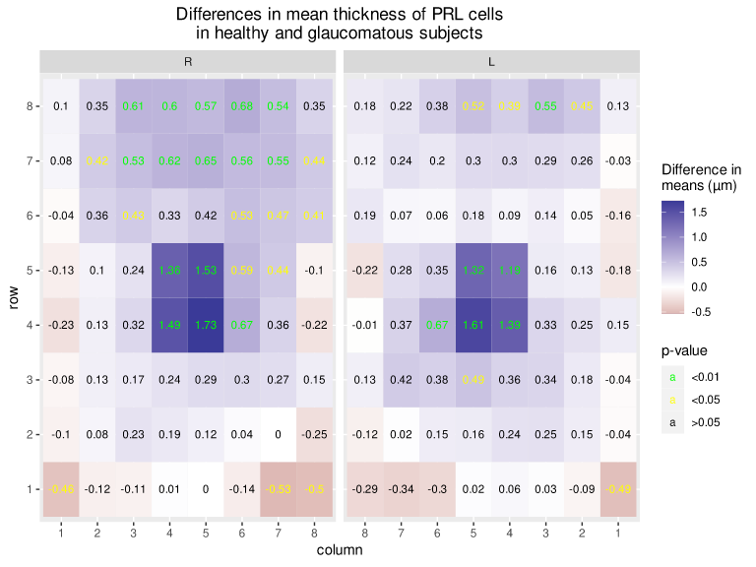

Figure 27. Heat map of differences in mean thickness (in µm) of PRL cells in healthy and glaucomatous subjects, according to left and right eyes.

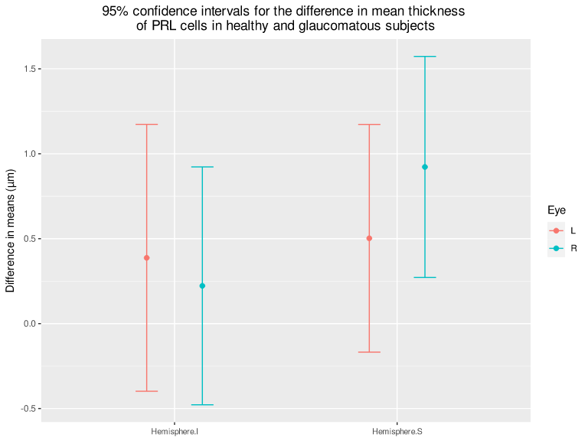

Figure 28. 95% confidence intervals for the difference in mean thickness of PRL cells in healthy and glaucomatous subjects, according to upper and lower half-planes and left and right eyes.

In the comparison by temporal and nasal half-plane (Error: Reference source not found), no statistically significant differences were observed in the mean thickness of the cells in healthy and glaucomatous subjects.

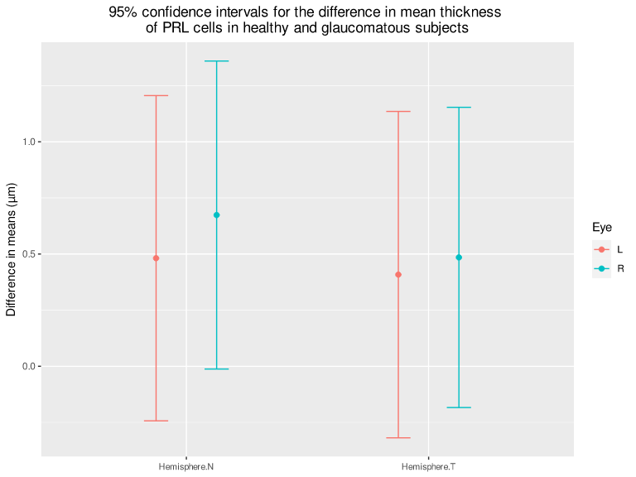

Figure 29. 95% confidence intervals for the difference in mean thickness of PRL cells in healthy and glaucomatous subjects, according to temporal and nasal half-planes and left and right eyes.

In the comparison by quadrant (Error: Reference source not found), no statistically significant differences were observed in the mean thickness of the cells in healthy and glaucomatous subjects, with the exception of right eyes in the upper nasal and upper temporal quadrants.

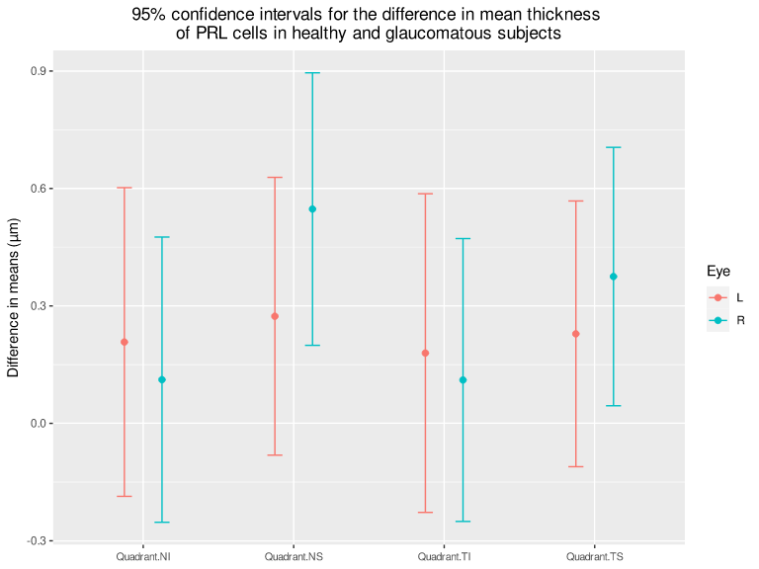

Figure 30. 95% confidence intervals for the difference in mean thickness of PRL cells in healthy and glaucomatous subjects, according to quadrants and left and right eyes.

## RPE

According to the correlation matrix of macular cube cells in Error: Reference source not found, no strong correlation was observed in RPE cell thickness, with the exception of contiguous cells, which show a strong correlation.

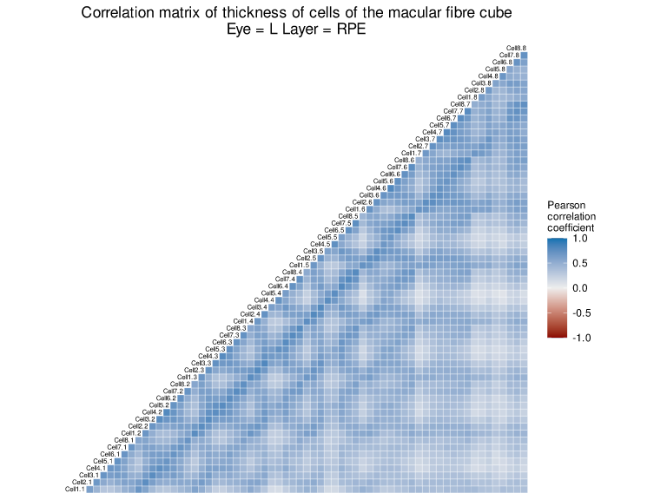

Figure 31. Correlation matrix of thickness of RPE cells of the macular cube of left eyes (right eyes present the same behaviour).

In the comparison of the mean thickness of RPE cells (Error: Reference source not found), an irregular pattern of differences in means in cell thickness was observed. The largest statistically significant negative differences in the mean thickness of the cells in healthy and glaucomatous subjects are found at the temporal margin and in cells 1.7 and 1.8. The largest statistically significant positive differences are found in the central region, specifically in cells 5.4 and 5.5. As in the other outer layers, the magnitude of the differences is small. The pattern is repeated in both left and right eyes, showing an almost perfect symmetry.

In the comparison by upper and lower half-plane (Error: Reference source not found), no statistically significant differences were observed in the mean thickness of the cells in healthy and glaucomatous subjects in both half-planes, for both left and right eyes. Likewise, no statistically significant difference was observed between the differences in means of the half-planes.

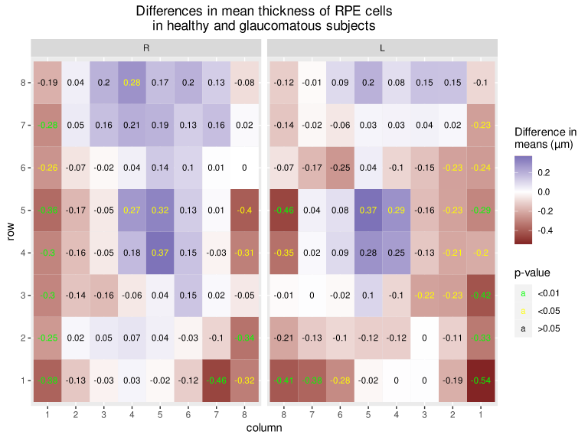

Figure 32. Heat map of differences in mean thickness (in µm) of RPE cells in healthy and glaucomatous subjects, according to left and right eyes.

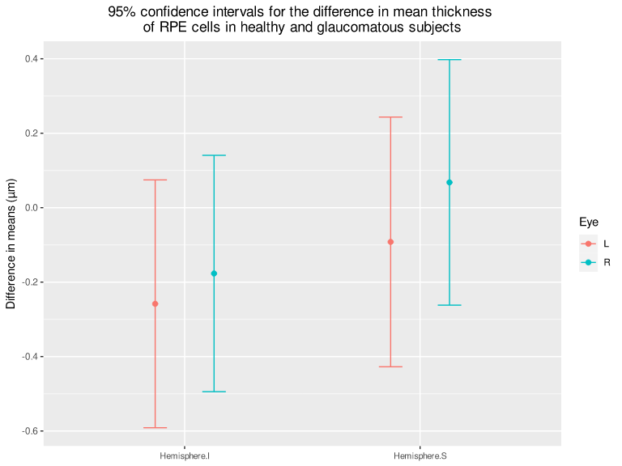

Figure 33. 95% confidence intervals for the difference in mean thickness of RPE cells in healthy and glaucomatous subjects, according to upper and lower half-planes and left and right eyes.

In the comparison of temporal half-planes (Error: Reference source not found), no statistically significant differences were observed in the mean thickness of the cells in healthy and glaucomatous subjects in both half-planes, for both left and right eyes. Likewise, no statistically significant difference was observed between the differences in means of the half-planes.

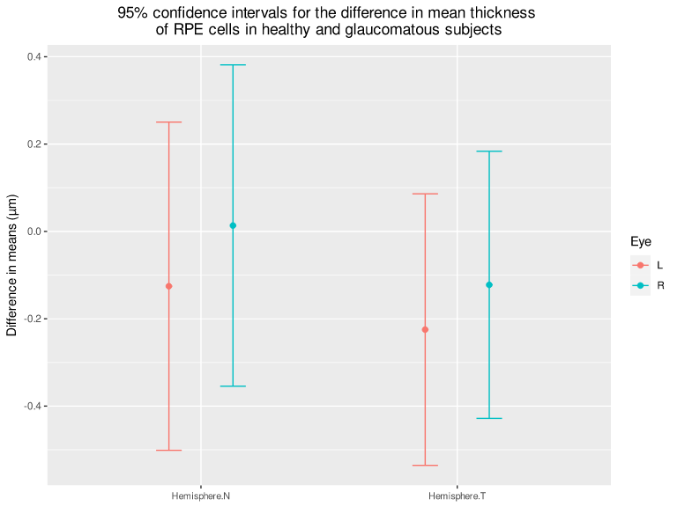

Figure 34. 95% confidence intervals for the difference in mean thickness of RPE cells in healthy and glaucomatous subjects, according to temporal and nasal half-planes and left and right eyes.

In the comparison by quadrant (Error: Reference source not found), no statistically significant differences were observed in the mean thickness of RPE cells in healthy and glaucomatous subjects in all quadrants, for both left and right eyes. No statistically significant differences were observed between the differences in means of the quadrants.

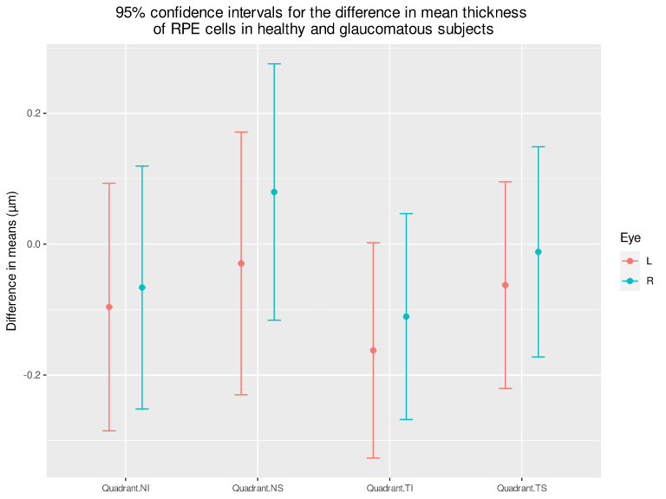

Figure 35. 95% confidence intervals for the difference in mean thickness of RPE cells in healthy and glaucomatous subjects, according to quadrants and left and right eyes.

## Inner layers (RNFL + GCL + IPL)

According to the correlation matrix of macular cube cells in Error: Reference source not found, a moderate to strong correlation was observed in cell thickness in the aggregation of inner layers (RNFL + GCL + IPL), with the exception of central cells 4.4, 4.5, 5.4 and 5.5, with a low correlation with the rest.

In the comparison of the mean thickness of RNFL + GCL + IPL cells (Error: Reference source not found), statistically highly significant differences were observed in the mean thickness of all the cells in healthy and glaucomatous subjects. The largest differences were observed in lower and upper nasal region cells 8.2, 7.2, 8.1, 8.8 and 8.7. On the other hand, the smallest differences were observed in the central cells and in the temporal region. The pattern is repeated in both left and right eyes, showing an almost perfect symmetry.

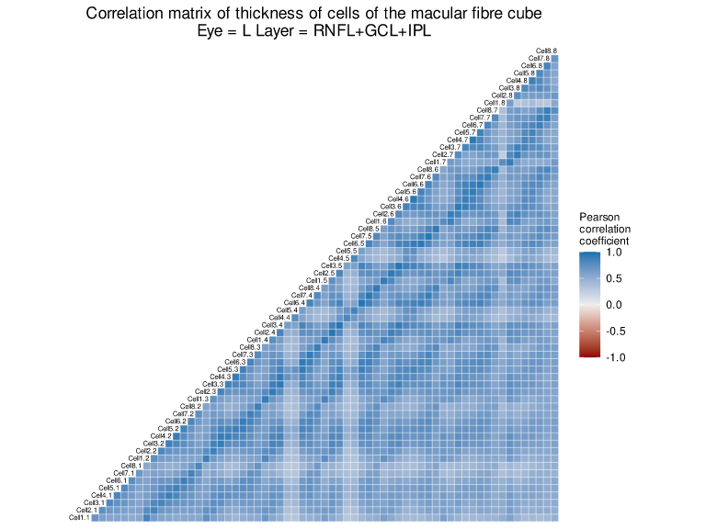

Figure 36. Correlation matrix of cell thickness in the aggregation of the inner layers (RNFL + GCL + IPL) of the macular cube of left eyes (right eyes present the same behaviour).

In the comparison by upper and lower half-plane (Error: Reference source not found), statistically significant differences were observed in the mean thickness of cells in the aggregation of the inner layers (RNFL + GCL + IPL) in healthy and glaucomatous subjects in both half-planes, for both left and right eyes. The difference in means in the lower half-plane was significantly greater than in the upper half-plane in right eyes, but not in left eyes.

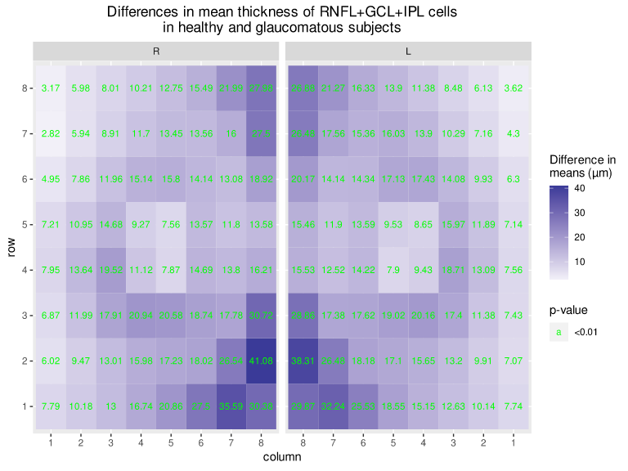

Figure 37. Heat map of differences in mean thickness (in µm) of cells in the aggregation of inner layers (RNFL + GCL + IPL) in healthy and glaucomatous subjects, according to left and right eyes.

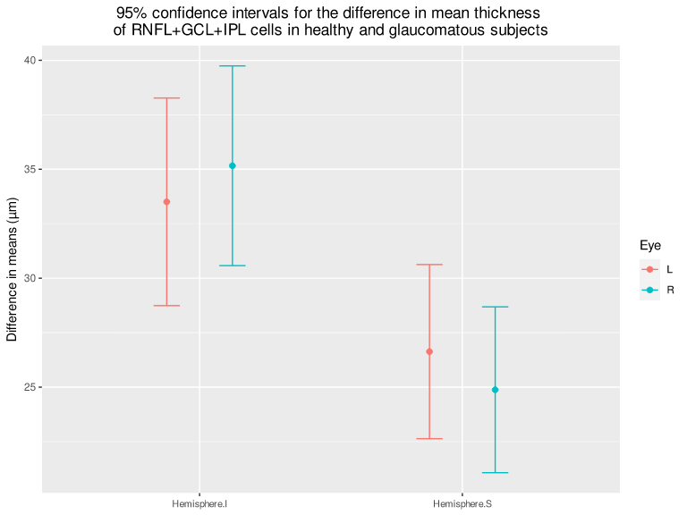

Figure 38. 95% confidence intervals for the difference in mean thickness of cells in the aggregation of inner layers (RNFL + GCL + IPL) in healthy and glaucomatous subjects, according to upper and lower half-planes and left and right eyes.

In the comparison by temporal and nasal half-plane (Error: Reference source not found), statistically significant differences were observed in the mean thickness of cells in the aggregation of the inner layers (RNFL + GCL + IPL) in healthy and glaucomatous subjects in both half-planes, for both left and right eyes. The difference in means in the nasal half-plane was significantly greater than in the temporal half-plane. Moreover, the difference between these half-planes is greater than between the upper and lower half-planes.

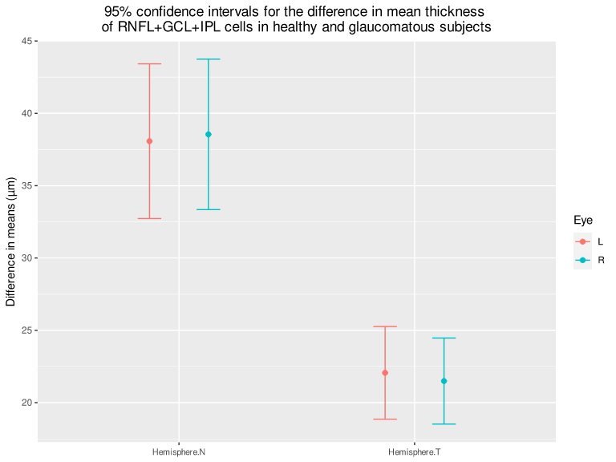

Figure 39. 95% confidence intervals for the difference in mean thickness of cells in the aggregation of inner layers (RNFL + GCL + IPL) in healthy and glaucomatous subjects, according to nasal and temporal half-planes and left and right eyes.

In the comparison by quadrant (Error: Reference source not found), statistically significant differences were observed in the mean thickness of RNFL + GCL + IPL cells in healthy and glaucomatous subjects in all quadrants, for both left and right eyes. The largest differences in means are found in the lower nasal quadrant and the smallest in the upper temporal quadrant, the differences in means in the nasal quadrants being significantly greater than in the temporal quadrants.

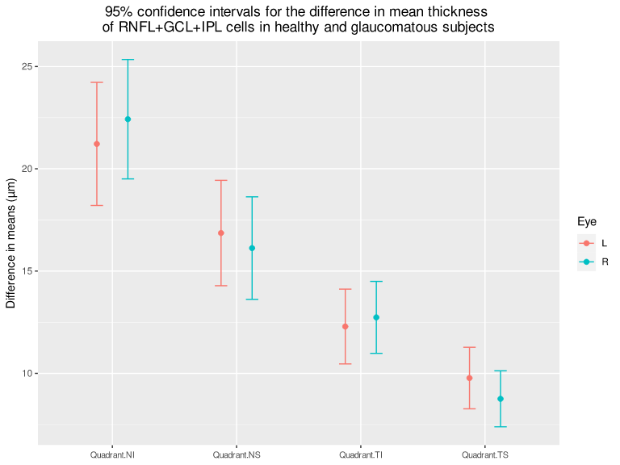

Figure 40. 95% confidence intervals for the difference in mean thickness of RNFL+GCL+IPL cells in healthy and glaucomatous subjects, according to quadrants and left and right eyes.

## Outer layers (INP + OPL + ONL + RPE)

According to the correlation matrix of macular cube cells in Error: Reference source not found, a moderate to strong correlation was observed in cell thickness in the aggregation of outer layers (INP+OPL + ONL + RPE), with the exception of central cells 4.4, 4.5, 5.4 and 5.5, with a low correlation with the rest.

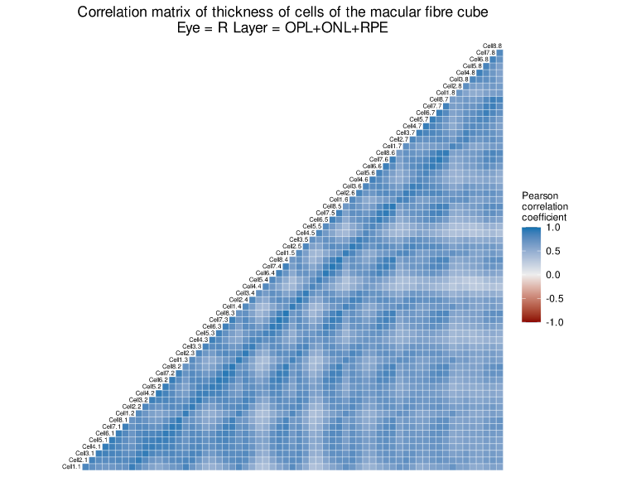

Figure 41. Correlation matrix of cell thickness in the aggregation of the outer layers (OPL + ONL + RPE) of the macular cube of left eyes (right eyes present the same behaviour).

In the comparison of the mean thickness of OPL + ONL + RPE cells (Error: Reference source not found), statistically highly significant positive differences were observed in the mean thickness of cells in healthy and glaucomatous subjects in the upper region, and statistically highly significant negative differences were observed in the lower nasal region, specifically in cells 1.7 and 2.8. No statistically significant differences were found in the other cells. In comparison with the inner layers, the differences between healthy and glaucomatous eyes are much smaller. The pattern is repeated in both left and right eyes, showing an almost perfect symmetry.

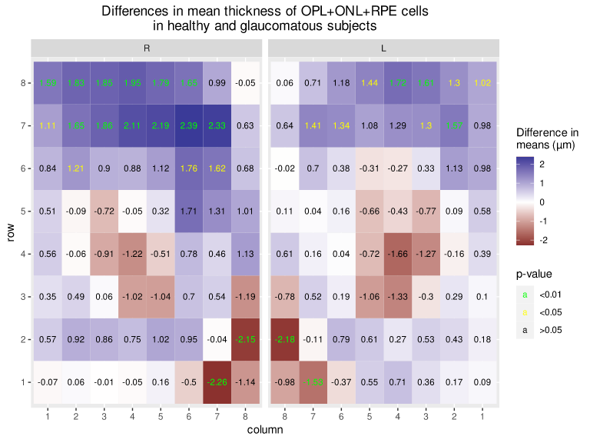

Figure 42. Heat map of differences in mean thickness (in µm) of cells in the aggregation of outer layers (OPL + ONL + RPE) in healthy and glaucomatous subjects, according to left and right eyes.

In the comparison by upper and lower half-plane (Error: Reference source not found), no statistically significant differences were observed in the mean thickness of cells in the aggregation of the outer layers (OPL + ONL + RPE) in healthy and glaucomatous subjects in both half-planes, with the exception of the upper half-plane of the right eyes. No statistically significant difference was observed between the differences in means of both half-planes.

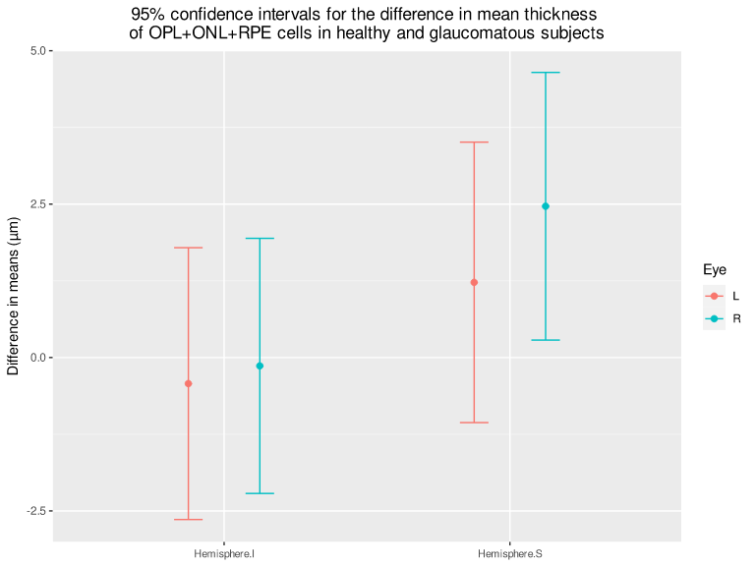

Figure 43. 95% confidence intervals for the difference in mean thickness of cells in the aggregation of outer layers (OPL + ONL + RPE) in healthy and glaucomatous subjects, according to upper and lower half-planes and left and right eyes.

In the comparison by temporal and nasal half-plane (Error: Reference source not found), no statistically significant differences were observed in the mean thickness of cells in the aggregation of the outer layers (OPL + ONL + RPE) in healthy and glaucomatous subjects in both half-planes, for both left and right eyes. Likewise, no statistically significant difference was observed between the differences in means of both half-planes.

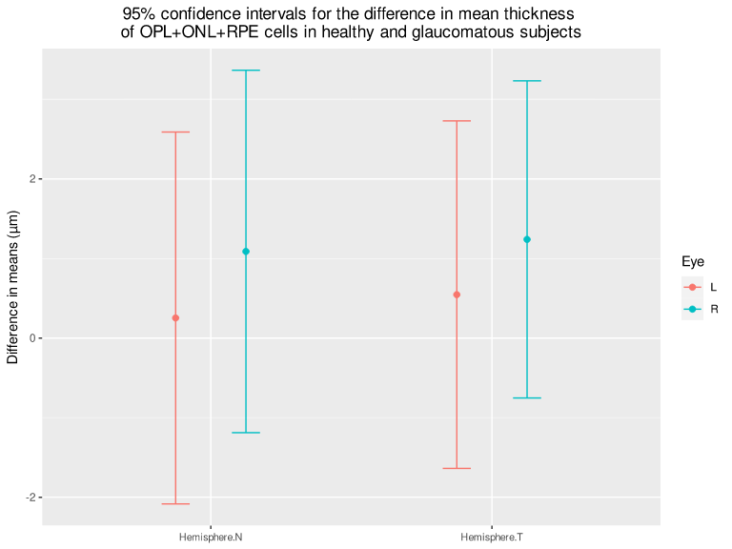

Figure 44. 95% confidence intervals for the difference in mean thickness of cells in the aggregation of outer layers (OPL + ONL + RPE) in healthy and glaucomatous subjects, according to temporal and nasal half-planes and left and right eyes.

In the comparison by quadrant (Error: Reference source not found), no statistically significant differences were observed in the mean thickness of OPL + ONL + RPE cells in healthy and glaucomatous subjects in all quadrants, with the exception of the upper quadrants of right eyes. No statistically significant differences were observed were observed between the differences in means of the quadrants.

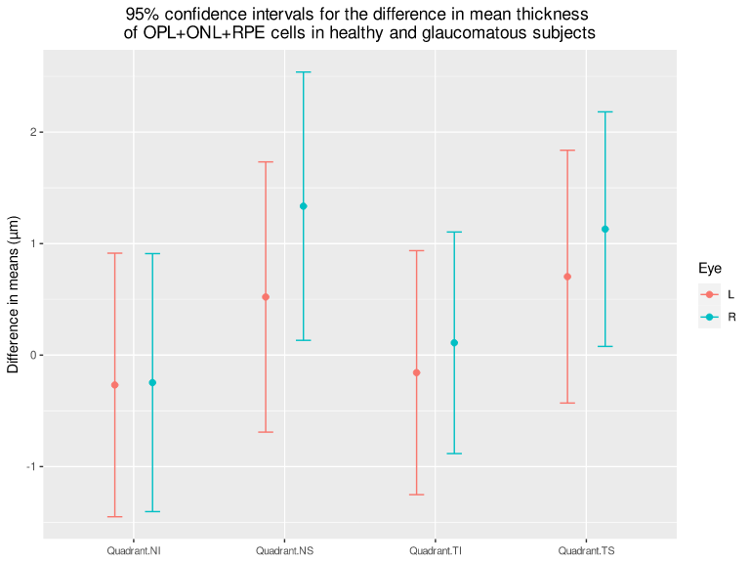

Figure 45. 95% confidence intervals for the difference in mean thickness of OPL+ONL+RPE cells in healthy and glaucomatous subjects, according to quadrants and left and right eyes.

# DISCUSSION

In this study we have analysed the central 20° of the macular area, the region of the eye with the highest density of ganglion cells (GC) and essential for vision. Although this area represents less than 2% of the retinal area, it contains more than 30% of the GC.2

We should be aware that glaucomatous damage to the macula is commonly accepted with certain discrepancies as regards specific locations. This damage occurs early in the disease and may go unnoticed and/or be underestimated with standard VF tests that use a 6° grid.

Individuals suspected of having glaucoma and those already diagnosed as having glaucoma usually undergo a standard test with automated static perimetry, using a test protocol in which the dots are 6° apart (e.g. protocol 24-2 or 30-2 of the Humphrey field analyser, Zeiss, Inc.). These tests, used in the most common protocols, would assess only the four central points (standard test 24-2, for example), this area having the highest retinal ganglion cell (RGC) density and the greatest concentration of cells involved in glaucomatous damage. The VF defects classification schemes of Keltner et al. did not consider this functional assessment.21,22

Therefore, in the present study, we highlight the value of macular segmentation as a way of assessing glaucomatous damage.

Building on previous work, Ehnes et al. developed a segmentation algorithm capable of individualising up to 11 intraretinal layers. Measurements with the algorithm were within the 95% confidence interval with a single rater and the difference was smaller and in less time than that obtained for the same fusion by qualified experts.23

Many other studies followed the path of retinal layer segmentation with discrepancies and accepted assumptions that increase as the technique improves. One of these general assumptions is the acceptance of the presence of damage at different levels of the macula in glaucoma. 3,6,24-27

Numerous authors have analysed the macula and its behaviour in glaucoma, proposing different assessment models in their work.7,12,18,28,29

With regard to the model we have defined in this paper for the assessment of MFL, only a few works, such as those of Ishikawa et al.,8 Kim et al.30 and Garía Medina JJ et al.31 are comparable.

While results of the assessment of the inner retina are similar in nearly all studies, for the outer retina they vary.

Ishikawa et al. determine the decrease in thickness in the GC and RNFL layers with 10 micron resolution time-domain OCT (TD-OCT). Acknowledging that there were difficulties in the structural differentiation of the retinal layers, they affirmed that there was a thinning of the GC and RNFL and a thickening of the outer retina. Their model was a 6 mm radial system with 6 meridians centred on the fovea.8

García Medina, JJ et al. make a grouping of the outer layers corresponding to ONL and OPL and also report thickening in areas of this grouping. The difference, in both studies, lies in the fact that the second one uses higher resolution, takes into account the disc-fovea axis and uses an 8 mm x 8 mm grid, making an analysis of each grid individually and analysis by upper and lower half-plane.31 Although in this study we also grouped these layers together, we did not find any statistically significant values, so we affirm that they do not contribute value to the search for typical glaucomatous lesions in the outer layers. We believe this affirmation is justified on the basis of our larger sample size.

If there were no errors in the segmentation of these layers, we could say that the behaviour of these two layers is inverse, since in the OPL there is a significant thickening of the upper half-plane whereas in the ONL there is a significant thinning. Precisely where no significant differences are observed in both layers is in the lower half-plane, which is exactly where García Medina, JJ et al. detect a significant thickening. This would be a discrepancy between the two studies.

Our study, more robust than the previous ones due to the larger sample size, also analyses the differences in the nasal and temporal half-planes, the quadrants (lower nasal, lower temporal, upper temporal and upper nasal), as well as the correlation between the cells of the macular cube, being similar to that of García Medina JJ et al.,31 although the latter did not analyse quadrants.

For a more optimal visualisation of the statistical results obtained, once they have been analysed in detail, we believe it is essential to carry out the discussion by analysing inner and outer layers. In our study we consider:

**- The outer layers**, where we include the INL, OPL + ONL, RPE and the complex formed by INP + OPL + ONL + RFE, due to their disparity in terms of the statistical values, which, not being statistically significant, we disregard in our search for information on glaucoma.

The correlation matrix, which could help us understand the atypical behaviour of some of the analysed cells, gives us results ranging from strong correlations between contiguous cells, as in the RPE layer, to moderate, low and even negative correlations within the same layer. This phenomenon occurs in both eyes (Figures 16, 21, 26, 31, 41).

In the cell-to-cell differences in thickness, the statistical values show an irregular pattern with such remarkable phenomena as the most statistically significant difference being between two contiguous cells but with opposite sign, i.e. cells 4.4 and 4.5 for the OPL and cells 4.4 and 5.6 in the ONL. What is striking is that these irregular patterns are present in both eyes (Figures 17, 22, 27, 32, 42).

With regard to the statistical values of the differences in thickness between the upper and lower half-plane and in the nasal and temporal half-planes, no significant statistical differences between the half-planes were observed in these four layers (Figures 18, 19, 23, 24, 28, 29, 33, 34, 43, 44).

As for the behaviour and statistical significance of the quadrants, they do not provide statistical significance in these outer layers (Figures 20, 25, 30, 35, 45).

All these disparate results lead us to advocate discarding these layers for any study until improved segmentation techniques or a better understanding of the histiology and physiology of these layers enable us to understand these results.

It is especially striking that these patterns are repeated in both the left and right eye, presenting an almost perfect symmetry.

One of the few anatomopathological studies of the retina in glaucomatous eyes, by Nork et al., which could support the thickening of the outer retina reported by some authors, refers to a possible edematization or inflammation of the apical part of the cones as a cause of the thickening of some areas of the outer retinal layers.32

We believe that the histopathological reference of Nork et al.32, which would support the inflammation theories of Ishikawa et al.8 and García Medina et al.31, should not be discarded, but as we wait for more precise histological studies to confirm this and a better structural and physiological knowledge of these layers, we believe we should ignore them for the assessment of glaucomatous damage in the macular area, however striking the symmetrical behaviour of both eyes may be.

The union of the four outer layers does not contribute more than what is observed in each of the individual layers separately.

**- In the inner layers**,where we have included RNFL, GCL and IPL because of their statistical significance, there is general acceptance about the thinning of these layers in glaucoma. Studies such as those by Kim HJ et al.30, García Medina, JJ et al.31 or Lin JP et al.33, which can be extrapolated to ours, report similar thinning behaviours of RNFL, GCL and IPL in early and advanced glaucoma.

In this study, the correlation matrix of the analysed cells, although its contribution is not especially remarkable, gives us a descriptive view of the cells and can explain the abnormal behaviour of some of these cells that could be used by AI to create useful algorithms for detecting glaucoma (Figures 1, 6, 11, 36).

Kim et al.30, in their white and grey maps, do not provide such precise information as that obtained in our study and that published by García Medina et al.31 We agree with the latter in highlighting that in the RNFL, the cells with the most significant statistical value are in the lower nasal quadrant, and, to a lesser degree, in the upper nasal quadrant (Error: Reference source not found), and in the GCL and IPL layers, it is the cells in the ring around the central area of the macula that also have a statistically highly significant value (Figures 2, 7, 12, 37 ). Our study also coincides with García Medina et al. in the comparison by upper and lower half-plane, where a significant thinning was observed in both half-planes in all three layers, being greater in the lower half-plane in the case of the RNFL (Figures 3, 8, 13). Our study also included a comparison by temporal and nasal half-plane, which allowed us to observe asymmetric thinning in RNFL, where the thinning is much greater in the nasal half-plane (Error: Reference source not found); as well as by quadrant, where asymmetry was also observed, with the greatest differences in the lower nasal quadrant, followed by the upper nasal quadrant (Error: Reference source not found). In the GCL and IPL layers, the pattern observed in these two half-planes was less asymmetric, with slightly greater thinning in the temporal half-plane, but with less substantial differences with respect to the nasal half-plane (Figures 4, 9, 14).

When we aggregate the inner layers RNFL, GCL and IPL, we find a strong pattern, which we propose as being typical of glaucoma and therefore recognisable in glaucoma. On the one hand there is a moderate to strong correlation in cell thickness, with the exception of central cells 4.4, 4.5, 5.4 and 5.5 (Figure 36), and on the other hand there are statistically very significant differences between the mean thicknesses of all cells in healthy individuals and glaucomatous patients, with the largest differences in the peripheral cells of the lower nasal region and the smallest in the central cells, which are precisely the least correlated with the other cells (Figure 37). Aggregating the cells by region, it can be stated that the largest differences are found in the lower nasal quadrant, followed by the upper nasal quadrant (Figure 40), whereas by half-plane, the differences in the lower half-plane are greater than in the upper half-plane (Error: Reference source not found) and the differences in the nasal half-plane are greater than in the temporal half-plane (Error: Reference source not found).

In conclusion, we can state that studying the RNFL, GCL and IPL layers and grouping them together provide significant differential information between healthy individuals and glaucomatous and/or ocular hypertensive patients. Each of these layers presents a characteristic pattern as a particular and specific response to glaucomatous damage, possibly deriving from their anatomical structure and physiological specificity. Together, as well as individually, they provide us with valid data for diagnosing early glaucoma, as well as for clinical-evolutionary staging. This is precisely our next objective: to develop a predictive model using artificial-intelligence techniques in order to classify the different stages of glaucoma, similar to the one presented by Parra-Blesa et al. but based on the information provided by the macular fibre cube.34

# BIBLIOGRAPHY

1. Quigley HA. Neuronal death in glaucoma. *Progress in Retinal and Eye Research*. 1999;18(1):39-57. doi: https://doi.org/10.1016/S1350-9462(98)00014-7.

2. Curcio CA, Allen KA. Topography of ganglion cells in human retina. *J Comp Neurol*. 1990;300(1):5-25. https://doi.org/10.1002/cne.903000103. doi: 10.1002/cne.903000103.

3. Zeimer R, Shahidi M, Mori M, Zou S, Asrani S. A new method for rapid mapping of the retinal thickness at the posterior pole. *Invest Ophthalmol Vis Sci*. 1996;37(10):1994-2001.

4. Asrani S, Zeimer R, Goldberg M, Zou S. Application of rapid scanning retinal thickness analysis in retinal diseases. *Ophthalmology JID - 7802443*. 1997;104(7):1145. doi: 10.1016/s0161-6420(97)30170-5.

5. Zeimer R, Asrani S, Zou S, Quigley H, Jampel H. Quantitative detection of glaucomatous damage at the posterior pole by retinal thickness mapping. A pilot study. *Ophthalmology*. 1998;105(2):224-231. doi: S0161-6420(98)92743-9 [pii].

6. Wollstein G, Schuman JS, Price LL, et al. Optical coherence tomography (OCT) macular and peripapillary retinal nerve fiber layer measurements and automated visual fields. *Am J Ophthalmol*. 2004;138(2):218-225. doi: 10.1016/j.ajo.2004.03.019 [doi].

7. Lederer DE, Schuman JS, Hertzmark E, et al. Analysis of macular volume in normal and glaucomatous eyes using optical coherence tomography. *Am J Ophthalmol*. 2003;135(6):838-843. doi: S0002939402022778 [pii].

8. Ishikawa H, Stein DM, Wollstein G, Beaton S, Fujimoto JG, Schuman JS. Macular segmentation with optical coherence tomography. *Invest Ophthalmol Vis Sci*. 2005;46(6):2012-2017. doi: 46/6/2012 [pii].

9. Na JH, Sung KR, Baek S, Sun JH, Lee Y. Macular and retinal nerve fiber layer thickness: Which is more helpful in the diagnosis of glaucoma? *Invest Ophthalmol Vis Sci*. 2011;52(11):8094-8101. doi: 10.1167/iovs.11-7833 [doi].

10. Chauhan BC, Burgoyne CF. From clinical examination of the optic disc to clinical assessment of the optic nerve head: A paradigm change. *Am J Ophthalmol*. 2013;156(2):218-227.e2. doi: 10.1016/j.ajo.2013.04.016 [doi].

11. Schuman JS. Spectral domain optical coherence tomography for glaucoma (an AOS thesis). *Trans Am Ophthalmol Soc*. 2008;106:426-458.

12. Mwanza JC, Oakley JD, Budenz DL, Chang RT, Knight OJ, Feuer WJ. Macular ganglion cell-inner plexiform layer: Automated detection and thickness reproducibility with spectral domain-optical coherence tomography in glaucoma. *Invest Ophthalmol Vis Sci*. 2011;52(11):8323-8329. doi: 10.1167/iovs.11-7962 [doi].

13. Garcia-Martin E, Larrosa JM, Polo V, et al. Distribution of retinal layer atrophy in patients with parkinson disease and association with disease severity and duration. *Am J Ophthalmol*. 2014;157(2):470-478.e2. doi: 10.1016/j.ajo.2013.09.028 [doi].

14. Garcia-Martin E, Bambo MP, Marques ML, et al. Ganglion cell layer measurements correlate with disease severity in patients with alzheimer's disease. *Acta Ophthalmol*. 2016;94(6):e454-9. doi: 10.1111/aos.12977 [doi].

15. Garcia-Martin E, Polo V, Larrosa JM, et al. Retinal layer segmentation in patients with multiple sclerosis using spectral domain optical coherence tomography. *Ophthalmology*. 2014;121(2):573-579. doi: 10.1016/j.ophtha.2013.09.035 [doi].

16. Gonzalez-Lopez JJ, Rebolleda G, Leal M, et al. Comparative diagnostic accuracy of ganglion cell-inner plexiform and retinal nerve fiber layer thickness measures by cirrus and spectralis optical coherence tomography in relapsing-remitting multiple sclerosis. *Biomed Res Int*. 2014;2014:128517. doi: 10.1155/2014/128517 [doi].

17. Koh VT, Tham YC, Cheung CY, et al. Determinants of ganglion cell-inner plexiform layer thickness measured by high-definition optical coherence tomography. *Invest Ophthalmol Vis Sci*. 2012;53(9):5853-5859. doi: 10.1167/iovs.12-10414 [doi].

18. Mwanza JC, Durbin MK, Budenz DL, et al. Profile and predictors of normal ganglion cell-inner plexiform layer thickness measured with frequency-domain optical coherence tomography. *Invest Ophthalmol Vis Sci*. 2011;52(11):7872-7879. doi: 10.1167/iovs.11-7896 [doi].

19. Nakano N, Hangai M, Nakanishi H, et al. Macular ganglion cell layer imaging in preperimetric glaucoma with speckle noise-reduced spectral domain optical coherence tomography. *Ophthalmology*. 2011;118(12):2414-2426. doi: 10.1016/j.ophtha.2011.06.015 [doi].

20. Sánchez Alberca A. Bringing R to non-expert users with the package RKTeaching.boletín de estadística e investigacion operativa (BEIO). . . 2015;31(Num 2):170-188.

21. Hood DC, Raza AS, de Moraes CG,V., Liebmann JM, Ritch R. Glaucomatous damage of the macula. *Prog Retin Eye Res*. 2013;32:1-21. https://pubmed.ncbi.nlm.nih.gov/22995953; https://www.ncbi.nlm.nih.gov/pmc/articles/PMC3529818/. doi: 10.1016/j.preteyeres.2012.08.003.

22. Keltner JL, Johnson CA, Cello KE, et al. Classification of visual field abnormalities in the ocular hypertension treatment study. *Arch Ophthalmol*. 2003;121(5):643-650. doi: 10.1001/archopht.121.5.643 [doi].

23. Ehnes A, Wenner Y, Friedburg C, et al. Optical coherence tomography (OCT) device independent intraretinal layer segmentation. *Transl Vis Sci Technol*. 2014;3(1):1. doi: 10.1167/tvst.3.1.1 [doi].

24. Aulhorn E, Karmeyer H. Frequency distribution in early glaucomatous visual field defects. In: Greve E, ed. *Documenta ophthalmologica proceeding series. second international visual field symposium.* ; 1977:75-83.

25. Giovannini A, Amato G, Mariotti C. The macular thickness and volume in glaucoma: An analysis in normal and glaucomatous eyes using OCT. *Acta Ophthalmol Scand Suppl*. 2002;236:34-36. doi: 56 [pii].

26. Aulhorn E, Harms H. Early visual field defects in glaucoma. In: ; 1967:151-186. https://www.karger.com/DOI/10.1159/000389404. 10.1159/000389404.

27. Heijl A, Lundqvist L. The frequency distribution of earliest glaucomatous visual field defects documented by automatic perimetry. *Acta Ophthalmol (Copenh)*. 1984;62(4):658-664. doi: 10.1111/j.1755-3768.1984.tb03979.x [doi].

28. Kotowski J, Gadi,Folio LS FAU - Wollstein, Wollstein G FAU - Ishikawa, Hiroshi, et al. Glaucoma discrimination of segmented cirrus spectral domain optical coherence tomography (SD-OCT) macular scans. *The British journal of ophthalmology JID - 0421041*.

29. Cifuentes-Canorea P, Ruiz-Medrano J, Gutierrez-Bonet R, et al. Analysis of inner and outer retinal layers using spectral domain optical coherence tomography automated segmentation software in ocular hypertensive and glaucoma patients. *PLoS One*. 2018;13(4):e0196112. doi: 10.1371/journal.pone.0196112 [doi].

30. Kim HJ, Lee SY, Park KH, Kim DM, Jeoung JW. Glaucoma diagnostic ability of layer-by-layer segmented ganglion cell complex by spectral-domain optical coherence tomography. *Invest Ophthalmol Vis Sci*. 2016;57(11):4799-4805. doi: 10.1167/iovs.16-19214 [doi].

31. Garcia-Medina J, del-Rio-Vellosillo M, Palazon-Cabanes A, et al. Mapeo de los cambios de grosor en el glaucoma de las capas retinianas maculares segmentadas usando el programa de polo posterior de la tomografi­a de coherencia optica de dominio espectral. *Archivos de la Sociedad Espanola de Oftalmologi­a*. 2018;93. doi: 10.1016/j.oftal.2018.01.010.

32. Nork TM, Ver Hoeve JN, Poulsen GL, et al. Swelling and loss of photoreceptors in chronic human and experimental glaucomas. *Arch Ophthalmol*. 2000;118(2):235-245. doi: 10.1001/archopht.118.2.235 [doi].

33. Lin JP, Lin PW, Lai IC, Tsai JC. Segmental inner macular layer analysis with spectral-domain optical coherence tomography for early detection of normal tension glaucoma. *PLoS One*. 2019;14(1):e0210215. doi: 10.1371/journal.pone.0210215 [doi].

34. Parra-Blesa A, Sanchez-Alberca A, Garcia-Medina JJ. Clinical-evolutionary staging system of primary open-angle glaucoma using optical coherence tomography. *J Clin Med*. 2020;9(5):. doi:10.3390/jcm9051530. doi: 1530.